Skilling South Australia Projects: Instructions on the use of the Government of South Australia logo
The following technical specifications must be applied to the use of the Government of South Australia logo:
- The vertical, stacked GOSA logo should be the standard with the horizontal version used in instances where the design or application precludes the use of the standard form.
- The minimum size of the roundel should be 10mm in diameter. The logo should not be altered in any way. No part of the image may be recreated or redrawn and the logo must always retain its original proportions (proportions are maintained by holding down the shift key when re-sizing images). The logo may not be rotated.
- The logo must be protected by an isolation zone of 5mm of clear space on all sides, equal to half the size of the roundel (this applies to every version and all applications).
- The logo must be free of background colour changes.
- The full colour version of the GOSA logo is the preferred option where available.
- Reversed Government of South Australia logos (white) should only be used when the background colour is dark enough to provide strong contrast against the logo.
- Only one Government logo (department or agency logo) may appear on communication of any nature, including sponsorship.
- Where more than one government entity is involved, only the GOSA logo may be used, and multiple agencies should be identified in text.
More information on the application of the GOSA logo is detailed in the GOSA Branding Guidelines, available in the Skilling South Australia Projects Provider Toolkit.
In most cases, SSA projects will be funded by the Department and delivered by the funded organisation. This is referred to as ‘Supported by’ and the following logos apply to this application:
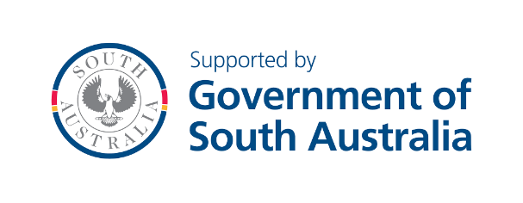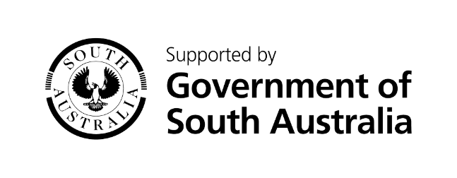

There may occasionally be cases where the Department has initiated a larger scale project. This is referred to as ‘Initiative of’ and should be branded with these logos:


Logos can be copied and pasted to your marketing materials. Please ensure that when re-sizing logos, the shift key is held down – this will maintain the logo proportions.
For further advice on referencing the Government of South Australia in marketing, promotion and publicity materials, email: dis.skillingsaprojects@sa.gov.au

